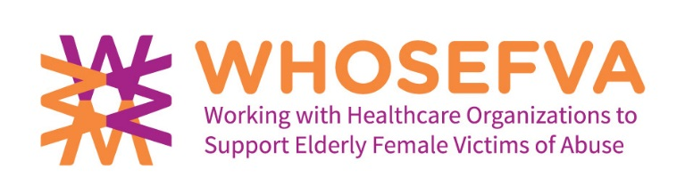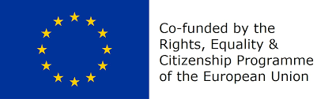
WHOSEFVA - Co-funded by the Rights, Equality and Citizenship (REC) Programme of the European Union under Grant Agreement no JUST/2015/RDAP/AG/VICT/9320
REPORT – TEMPLATE - FOR THE FOCUS GROUP
Focus groups of older female victims of violence or participants from communities
Dear Partner, Dear Facilitator,
For reporting and documentation, the focus groups please fill out this questionnaire/template immediate after the focus group.

Questions:
- WHOSEVFA-Partner and Country:
- Name(s) of the Facilitator(s):
- Name(s) of the Assistant(s):
- Number of Participants:
- Number of female Participants:
- Number of male Participants:
- Age of the Participants:
- Who were the participants?
(surviors or others)
- Date of Focus group:
- Place of the focus group:
- Durations/Time of the Focus group: (hours)
- Number of identified victims?
- Number of participants from communities?
- How did you find the participants? (searching process) (any difficulties?)

- Perceptions of the facilitators and assistant about the dynamics in the group (atmosphere, confidantiality, talked willingly, hesitated to talk, reserved, open, how the participants communicated with each other..) etc.)

- Description about the main results of the topic: Elder abuse/Violence against older people (Definition of elder abuse/violence against older people) (Most common forms of violence) (conflicts in violent relationships) (differences between women and men?)

- Description about the main results of the topic: Causes/factors behind elder abuse/ Violence against older people

- Description about the main results of the topic: Help seeking: (first services for support? Experiences about professionals? Expectations from them?

- Description about the main results of the topic: Seeking solutions (solving the violent situation) (kind of obstacles)

- Description about the main results of the topic: Effects of violence on the victims
(kind of emotional effects) (effects on your physical health) (violence influence the daily life)

- Description about the main results of the topic: Consequences for perpetrator(s)

- Description about the main results of the topic: Concerns of older victims regarding the services and treatment (most concerns regarding being older and having domestic violence problems)( concerns being older and seeking help from social and health care services)

- Description about the main results of the topic: What should be done?
(advices give another older person) (what are the top three needs of survivors) ( services most needed) (something that should be done at societal level)

- If possible please formulate three policy recommendations on advancing the healthcare policy towards elder victims of DV (for policy maker at the national and/or EU Level)

- What kind of oral feedback did you get from the participants?
- Is there something you would change in the focus group session? What?
- What did you learn from the focus group session and the participants?
- Any other comments?

Thank you for your support!

